Where’s My Refund?
As early as 24 hours after e-filing, or 4 weeks after your mailed return, the IRS provides a tool online to track the status of your refund for the current tax year and 2 prior years
What you will need:
- Social Security Number (SSN) or Individual Taxpayer ID Number (ITIN)
- Your filing status
- Your exact federal refund amount
To confirm your filing status, you can find that information at the top of the first page of your 1040 tax return.
To confirm the exact amount of your federal refund, you can find the amount on page 2 of your 1040 tax return, line 34.
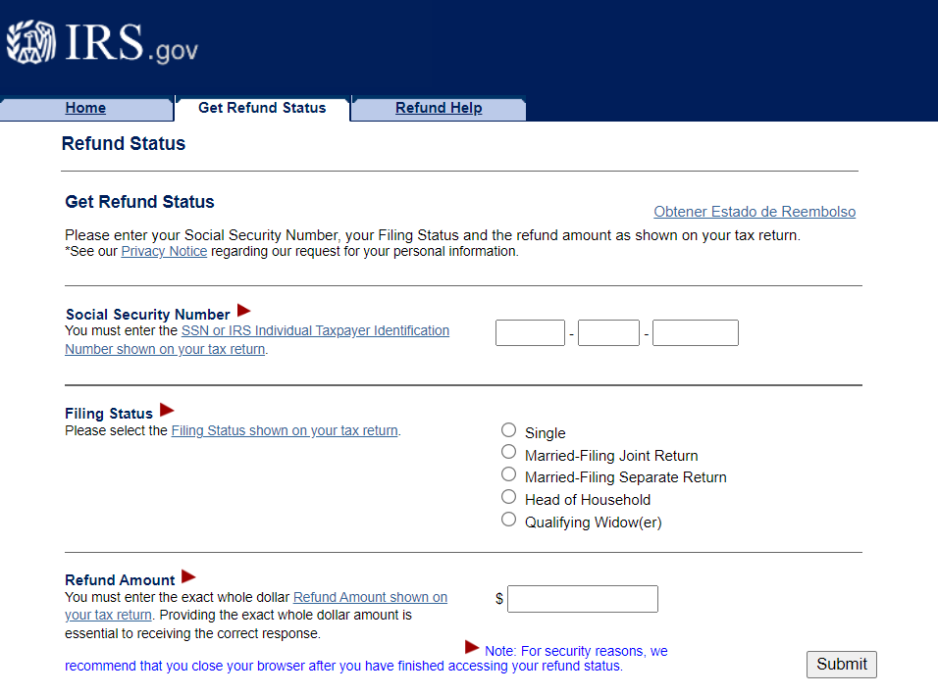
For the IRS Where’s My Refund tool, visit www.irs.gov/refunds
Similarly, you can visit www.ncdor.gov/refund to use the NC Dept of Revenue Where’s My Refund tool
(see back of page for guidance on when to call the IRS regarding a delay of your tax refund)

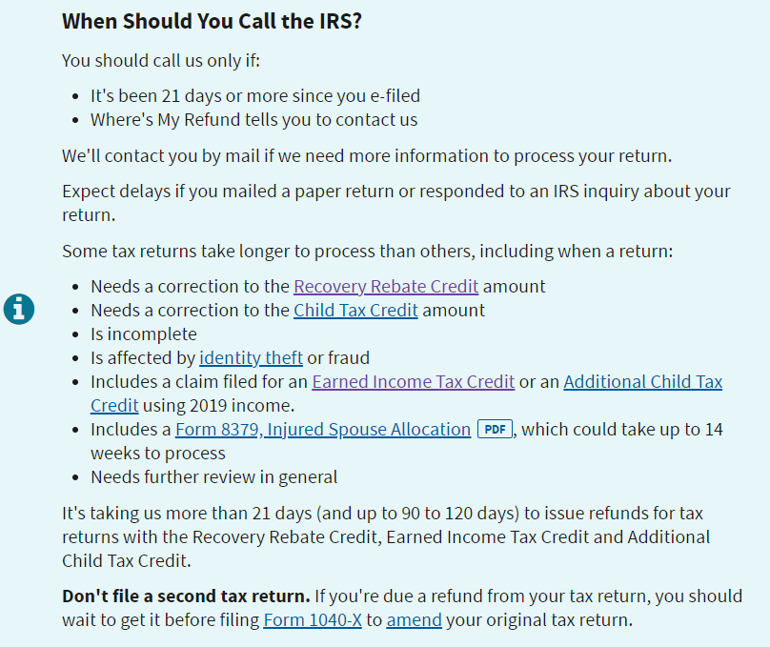

Still have questions? Please contact Pisgah Legal Services’ Health and Economic Opportunity Program directly by calling 828-210-3404, press 2 for taxes!

